## Wireframe 1, index:

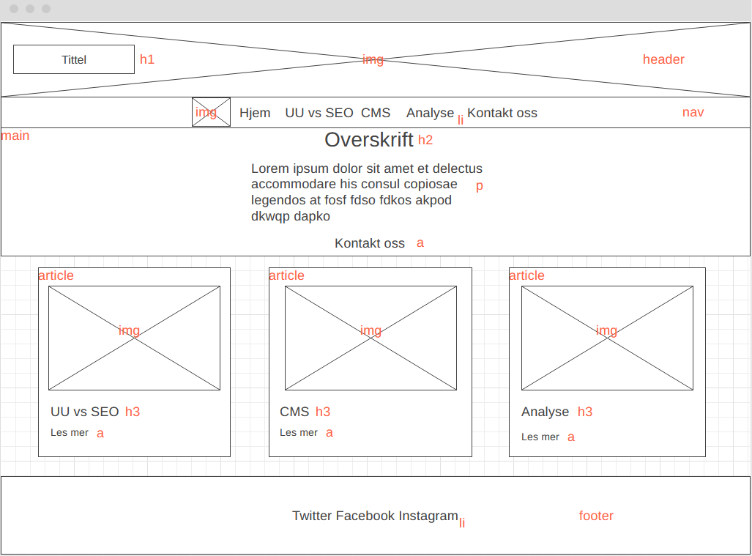

## Wireframe 2, innholdsside:

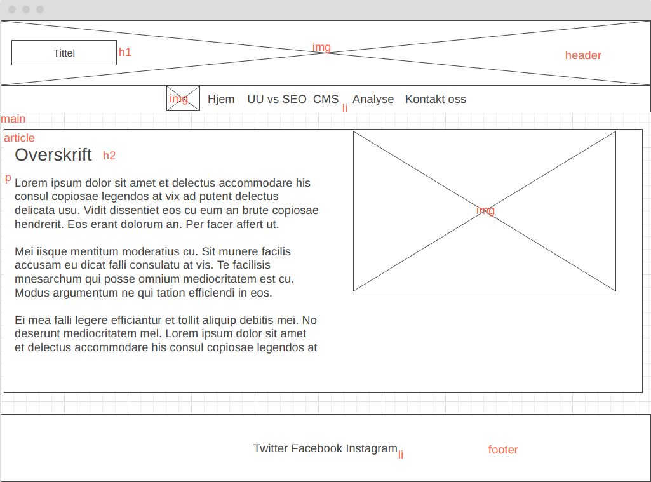

## Wirefram 3, Kontakt oss:

## Telefon Wirefram 1, index:

## Telefon Wireframe 2, innholdsside:

## Et bilde som inneholder bord Automatisk generert beskrivelseTelefon Wireframe 3, Kontakt oss:

## Kildeliste:

Background bilde snø: <https://unsplash.com/photos/PyR3GEiGkQM>

Kode for background: <https://www.w3schools.com/html/html_images_background.asp>

<https://necolas.github.io/normalize.css/8.0.1/normalize.css>

bilde skiing: <https://unsplash.com/photos/pmfJcN7RGiw>

bilde skating: <https://unsplash.com/photos/3k4PyCfGDLs>

bilde cabin: <https://unsplash.com/photos/kVKz9qnJC-k>

<https://fontawesome.com/>

Wireframe 1, index: <https://wireframe.cc/2HiOuO>

Wireframe 2, innholdsside: <https://wireframe.cc/0DIU05>

Wirefram 3, Kontakt oss: <https://wireframe.cc/iipwdb>

telefon Wirefram 1, index: <https://wireframe.cc/vRC5kl>

telefon Wireframe 2, innholdsside: <https://wireframe.cc/JzPo2u>

telefon Wireframe 3, Kontakt oss: <https://wireframe.cc/C8RHbC>